Directions: The goal of the following problems is to help challenge and deepen your understanding of the current topic. Don’t assume that you will know how to answer each and every question. You will work with at least two other students in the class to try and find solutions and write arguments for each of the following questions. Be sure that you question your classmates’ reasoning. If you don’t understand how they are getting something you should ASK THEM TO EXPLAIN! Being able to defend your reasoning is important and so you are actually helping them by asking them to explain.

Challenge Questions
- Consider the function .
- Fill out the following table of values for the function
x |  | -1 | 0 | 1 | 3
 |  |  | 0 |  | 9

We see that

- Provide a rough sketch of what the function looks like.

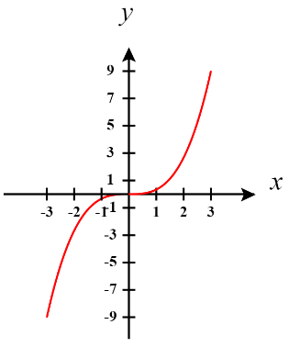

- Determine the value of .

According to the FTCP1 since is continuous on (regardless of the value of x) we know that .

Therefore,

- Find the derivative of the function .

The function is continuous on any interval and so is continuous on , so the FTCP1 can be applied.

Before we compute the derivative we note that .
Therefore, .

- Find the derivative of the function .

The function is continuous on any interval and so is continuous on , so the FTCP1 can be applied. Note that is always greater than and so the denominator will never equal 0.

Therefore, .

- Compute

The function is clearly continuous on any interval and so is continuous on , so the FTCP1 can be applied.

- Let .
- Use your calculator to graph this function on the interval .

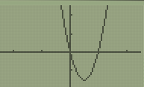

- Compute by first evaluating the integral using the FTCP2 and then differentiating.

The function is clearly continuous on any interval and so is continuous on , so the FTCP2 can be applied.

We see that . Therefore, .

- Compute by using the FTCP1 directly. Note that you will have to rewrite the function a bit first.

We see that
The function is clearly continuous on any interval and so is continuous on and , so the FTCP1 can be applied.

By the FTCP1 we know that

- Show that that the two results from parts (b) and (c) are consistent.

Indeed, the answer from parts (b) and (c) are both

- Determine the equation of the tangent line to at .
We first try to find the y-value of the point where .
We then need to compute the derivative of this function and find the slope of the tangent line.

The function is clearly continuous on any interval and so is continuous on , so the FTCP1 can be applied.

Therefore, the equation of the tangent line at is

- Let .
- Find all intervals where is increasing.

The function is clearly continuous on any interval and so is continuous on , so the FTCP1 can be applied.

We first compute .
We see that when .
is never undefined.

$$-$$
$$+$$

is increasing on .

- Find all intervals where is concave up.

We must compute
We see that when
is never undefined.
$$-$$
$$+$$
$$-$$

- Compute the maximum of the function .
We simplify in the following way:

The function is continuous on any interval and so is continuous on , so the FTCP1 can be applied.

Now we calculate that

We see that will never be undefined and when

We put this value on a number line and test values of the derivative on either side.
$$+$$
$$-$$
$$MAX$$

We see that at there is a maximum. We can see that this corresponds to an absolute maximum since there are no other critical points on the function .

- Find the maximum value of the area of the region under the curve from to , for all .

We note that we are trying to maximize

To do this we calculate

when . Since we only use
is never undefined.

$$+$$
$$-$$
$$MAX$$
So, the maximum value of the area occurs on the interval

- If , where f is a continuous function, find .

We differentiate both sides here and find that .

This implies that .
Since we want to know we will evaluate the previous line when .
Therefore we have,

